Apps to help with Remote Learning

This is a list of things you can do to make reading and writing easier when you are learning from home. Each section has a link for how to do it on Google, Apple, Microsoft or Android. Just click the one for the device you use.

 Help with reading

- Reading websites and work out loud

Google Chrome 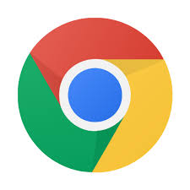

- Read Aloud - When you have installed it in google chrome, you can select whatyou want to read and click the loudspeaker icon. ://chrome.google.com/webstore/detail/read-aloud-a-text-to-spee/hdhinadidafjejdhmfkjgnolgimiaplp?hl=en
- You can turn on ‘Screen Reader’ in your school google account
Get help reading text on a screen - Computer - Google Account Help

iPAD/iOS 
- ‘Speak selection’ or ‘Speak Screen
Using Speak Selection on Your Ipad
- Text to Speech on iPads and iPhones

Microsoft Word 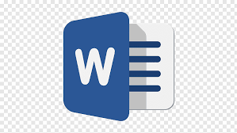

- You can download this and add it to Word https://www.wordtalk.org.uk/home/
- You can use the Microsoft Windows dictation command for your whole windows computer https://www.wikihow.com/Dictate-on-Word
- You can use ‘Speak text to speech’ in Word or Powerpoint Use the Speak text-to-speech feature to read text aloud

Android 
- Select to Speak - Android Accessibility Help
- Text-to-speech output - Android Accessibility Help
- Text To Speech Reader (download the app)

2. Pain or headaches or blurry vision when you read:
Change the background colour or add a tint to the screen

Google chrome

- Colour Overlay for Google Chrome to reduce the contrast - Ad Added Color Overlay 2

iPAD/iOS

- How to use Display Accommodations on iPhone and iPad

Microsoft Word

- Add, change, or delete the background color in Word

Android
- Download a colour overlay app like Screen Overlays play.google.com/store/apps/details?id=com.devahead.screenoverlays
- Or Tintvision play.google.com/store/apps/details?id=com.emcreations.tintvision&hl=en_GB

3. Make the writing bigger:

Google Chrome

- Change text, image and video sizes (zoom) - Google Chrome Help

iPAD/iOS

- Use the ‘Zoom’ function - How to use Zoom in Accessibility on iPhone and iPad
- Using the Ipad to Support Learners with Visual Difficulties

Microsoft Word
- Change the font size

Android
- Magnification - Android Accessibility Help
- Font size and display size - Android Accessibility Help

Help with writing

Speaking what you want to type (dictation)

Google Chrome

- Google Docs Open a new document and clicking ‘Tools’ and selecting ‘voice typing’ Voice Typing in Google Docs

iPAD/iOS

- Speaking what you want to type (dictation)
https://www.callscotland.org.uk/information/speech-recognition/siri/

Microsoft office (Word)

- Dictate is an app you can download and add to Microsoft word
- You can use a tool in Word to let you speak what you want to write - instructions here: Dictate text using Speech Recognition - Windows Help

Android

- Use google voice typing on your device Android

Help with new/tricky word meanings

- An excellent online dictionary with simple, easy to understand definitions is Cambridge Learner’s Dictionary - Definitions & Meanings

- You can search by saying the word in the Merriam Webster dictionary , so spelling isn’t important. Dictionary by Merriam-Webster: America's most-trusted online dictionary use online or download app for apple/android.

- Merriam Webster Visual Dictionary - This uses images to help you remember word meanings http://www.visualdictionaryonline.com/index.php use online or download app for apple/android.

